\*Newly Negotiate Premiums for 2020 Upon Ratification \*\***Updated 8/20/19\*\*\***

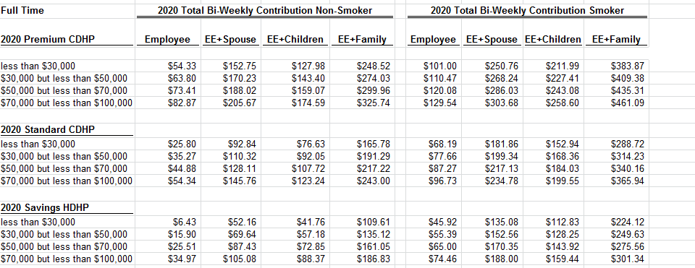

\*Previously Negotiated premium rates negotiated in 2017 for 2020 that will be replace with the above rates if the new agreement is ratified.

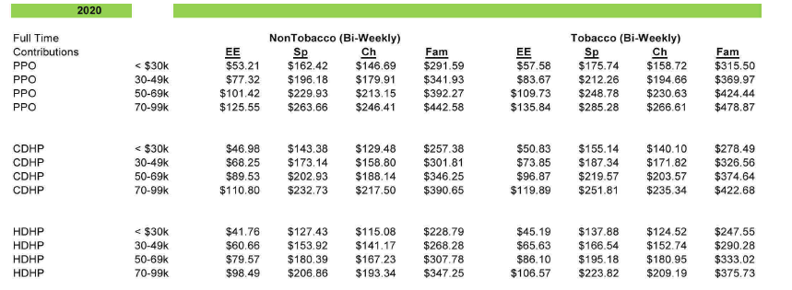

Newly Negotiated Plan Design would be in effect January 1, 2020 upon ratification



Previous Plan design negotiated in 2017

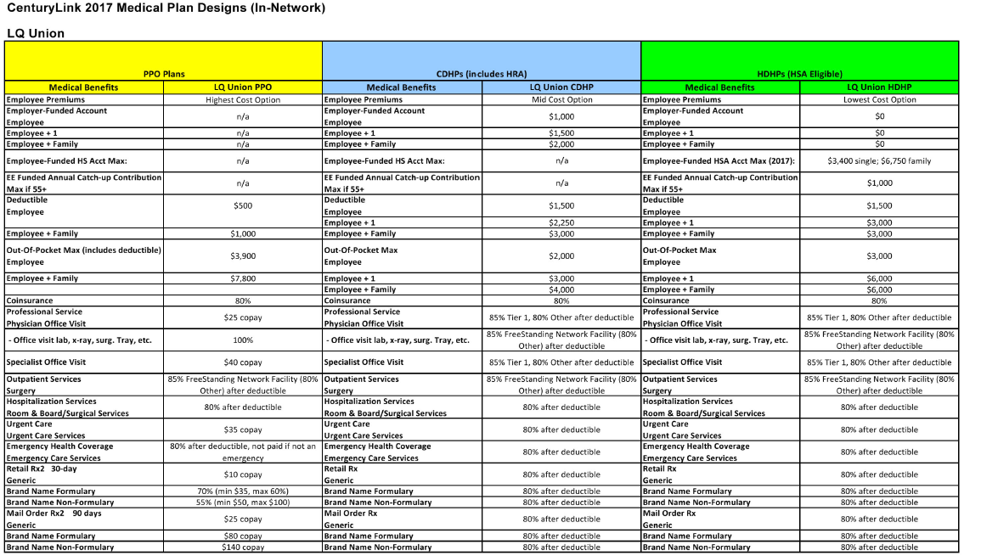

Vision/Dental Newly Negotiated Premiums upon ratification

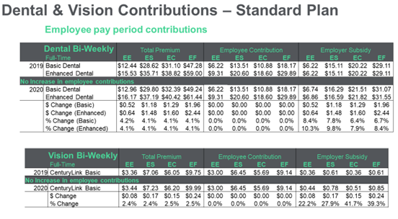

Previously Negotiated Rates that will change to the above rates if the new agreement is ratified.

